
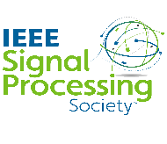



IEEE SPS SBC SNGCE

TABLE OF CONTENTS

- IDEATHON REPORT
- DECODE THE SIGNAL REPORT
- WEBINAR-AUGMENTED REALITY REPORT
- EXECOM TRAINING REPORT
- PHOTOGRAPHY CONTEST REPORT
- EXECOM MEETING REPORT
- QUIZ COMPETITION-ENGINEERS DAY REPORT
- WEBINAR REPORT
- HANDS- ON WORKSHOP ON PYTHON WEEK 1 REPORT
- HANDS- ON WORKSHOP ON PYTHON WEEK 2 REPORT
- HANDS- ON WORKSHOP ON PYTHON WEEK 3 REPORT

IDEATHON
Mode : Online
Participation Count : 5
Date : 31st May2023
Platform : Google Meet

An Ideathon on “SIGNAL PROCESSING IN DAILY LIFE” was conducted by IEEE SB MBITS in association with IEEE SB SNGCE and IEEE SB MACE as a part of inception, which is an inter-cluster event organised by IEEE SPS Kerala chapter as a part of 75th anniversary of IEEE SPS. It is a short, intensive brainstorming event to help young talents generate fresh solution to existing challenges in communities. 5 students actively participate in this event.
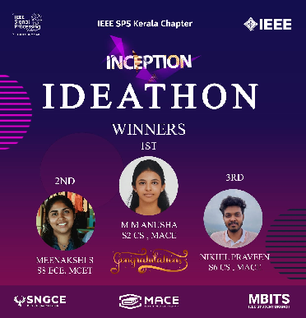
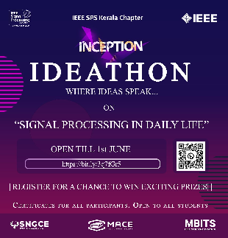

DECODE THE SIGNAL-TECHNICAL QUIZ COMPETITION

Mode : Online
Participation Count : 12
Date : 30th May2023
Time : 7:00 to 8:00 pm
Platform : Google Meet

A technical quiz competition on Decode The Signal was conducted by IEEE SB MACE in association with IEEE SB SNGCE and IEEE SB MBITS as a part of inception, which is an inter-cluster event organised by IEEE SPS Kerala chapter as a part of 75th anniversary of IEEE SPS. It aims to test participant’s knowledge and understanding of signal processing. The quiz consist of series of multiple choice question related to signal processing, AI and IOT. 12 students were actively participated in this competition.

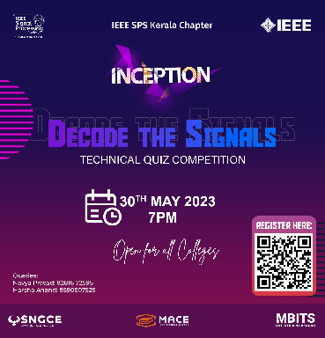

WEBINAR - AUGMENTED REALITY

Mode : Online
Participation Count : 33
Date : 31st May2023
Time : 7:00 to 8:00 pm
Platform : Google Meet

A webinar on Augmented Reality was conducted by IEEE SB SNGCE in association with IEEE SB MACE and IEEE SB MBITS as a part of Inception, which is an inter-cluster event organised by IEEE SPS Kerala chapter as a part of 75th anniversary of IEEE SPS. The session was handled by Mr. Salih Yoosaf, Meta Spark AR Developer, Virtual Events and Partnership Associate at Entri app. The event was held at 7:00 pm on 31st May 2023. The meeting started with a welcome speech followed by the webinar and vote of thanks. During the session, Mr.Salih explained about the Augmented Reality using Meta Spark AR Studio software .At the end of the meeting Q&A session were also conducted. The session was well-loved by the participants.

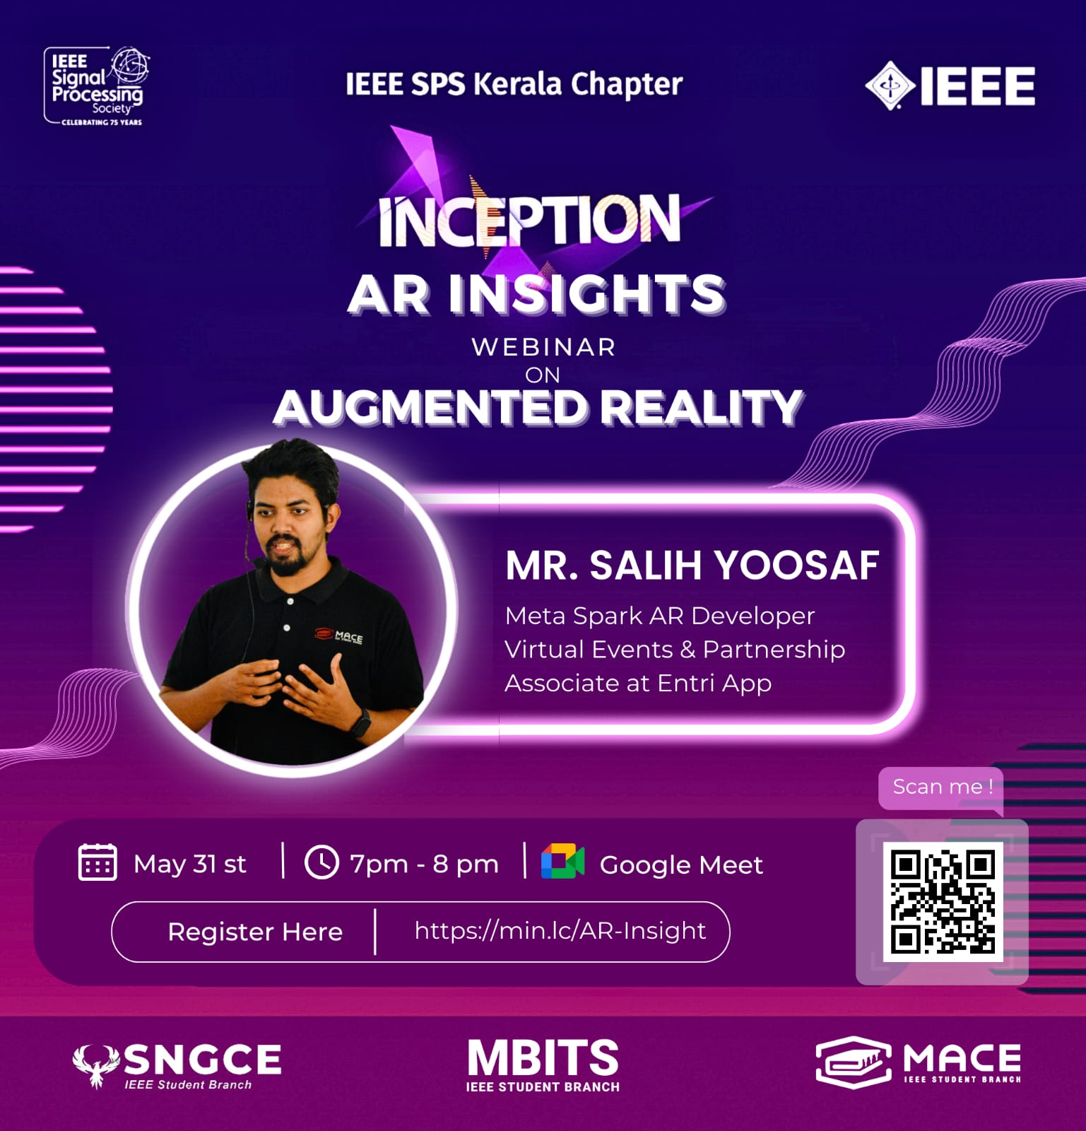
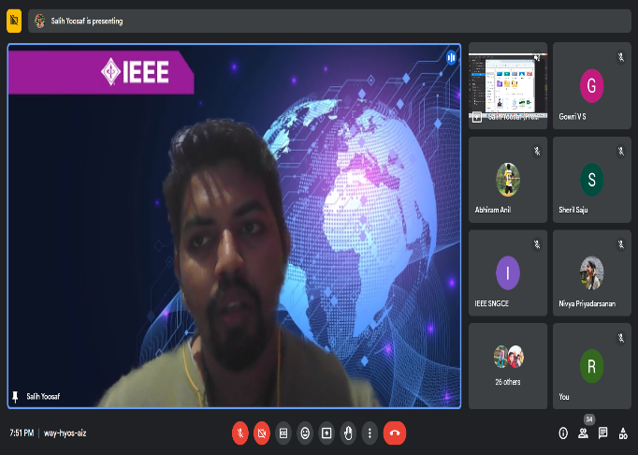
EXE COM TRAINING
Mode : Offline
Participation Count: 27
Date : 8th June 2023
Time : 3pm
Venue : PG Seminar Hall

IEEE SB SNGCE had organized an EXE-COM Training for all the EXE-COM members. The training was handled by all the ex-execom members. They shared their valuable experience and gave advice for everyone. They taught about all the responsibilities and roles of each post that were handled by the exe com members. They also shared tips about how to conduct events and properly maintain them. The exe com members shared their doubts and thoughts on their role and the ex- exe com members cleared them. Finally ,they discussed the upcoming events and confirmed the date and venue.

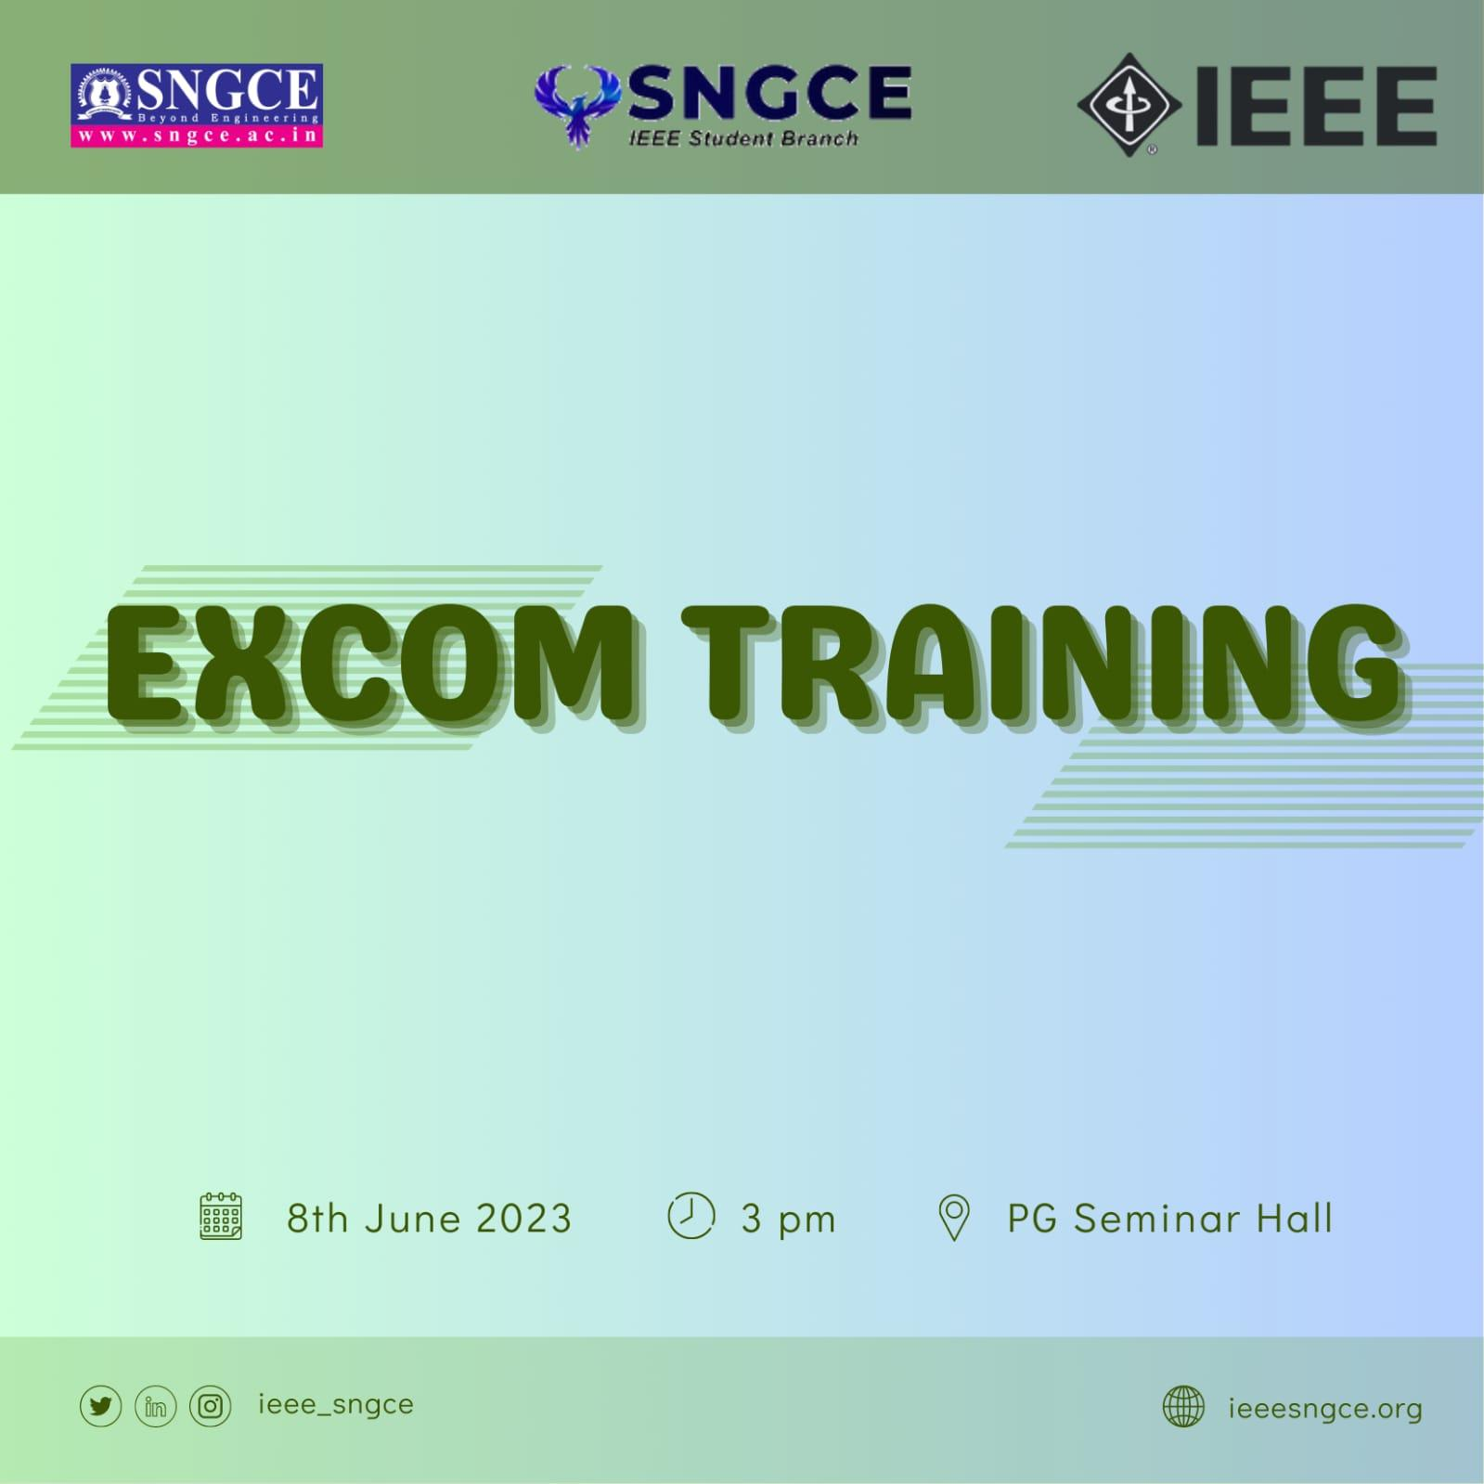

PHOTOGRAPHY CONTEST

Mode : Online
Participation Count : 20
- IEEE Members : 6
- Non IEEE Members : 14
Date : 18th -21st August 2023

IEEE SPS SB SNGCE organized an online mobile photography contest from 18th to 21st of August 2023.The contest based poster, writeup and google form with registration link was shared to the students through WhatsApp. The four days long contest collected the entries through google form as it’s mode of registration to the competition. A total of 20 including students and staffs from various departments participated in the contest
The theme for the photography contest was understanding clouds. The selection process for winners was purely based on the theme. The best uploaded snap for the theme was selected and declared as the winner.

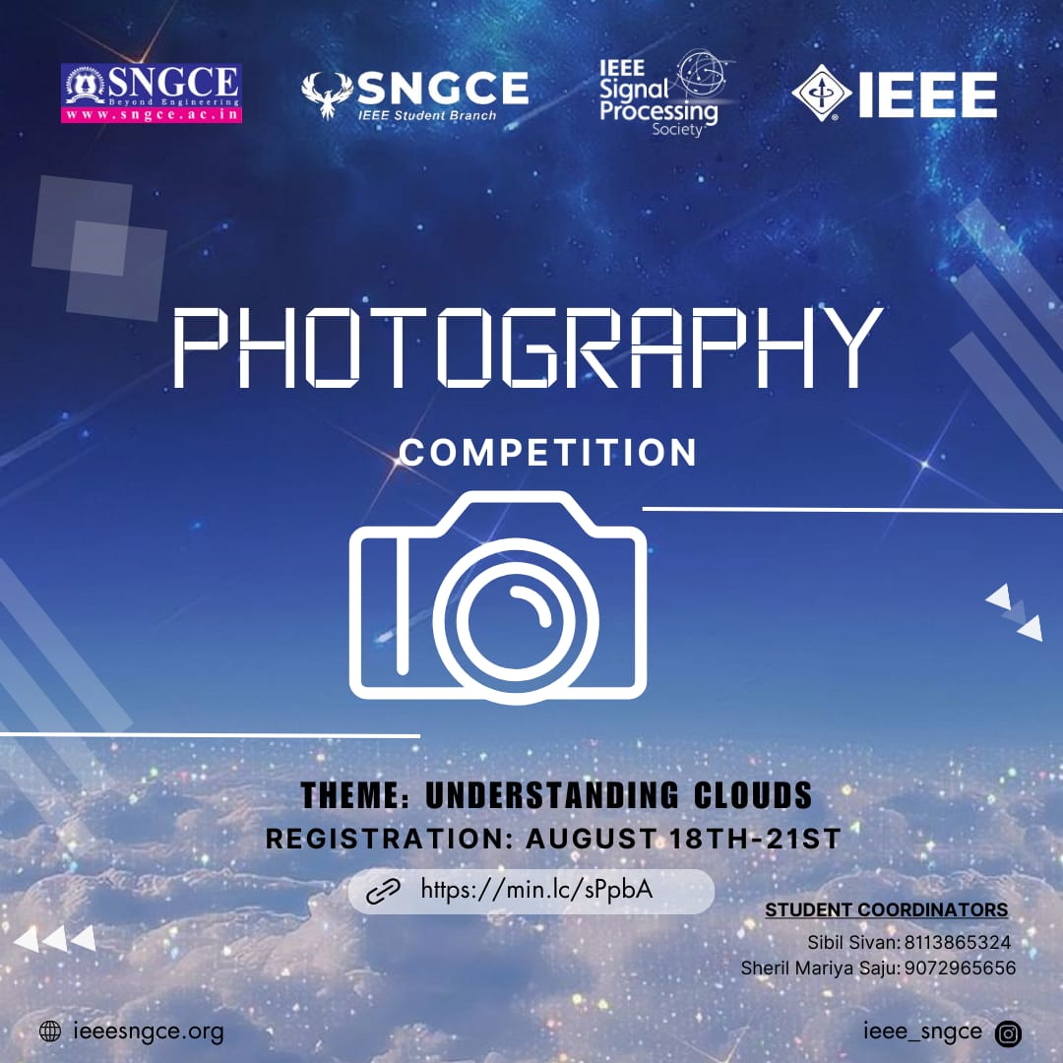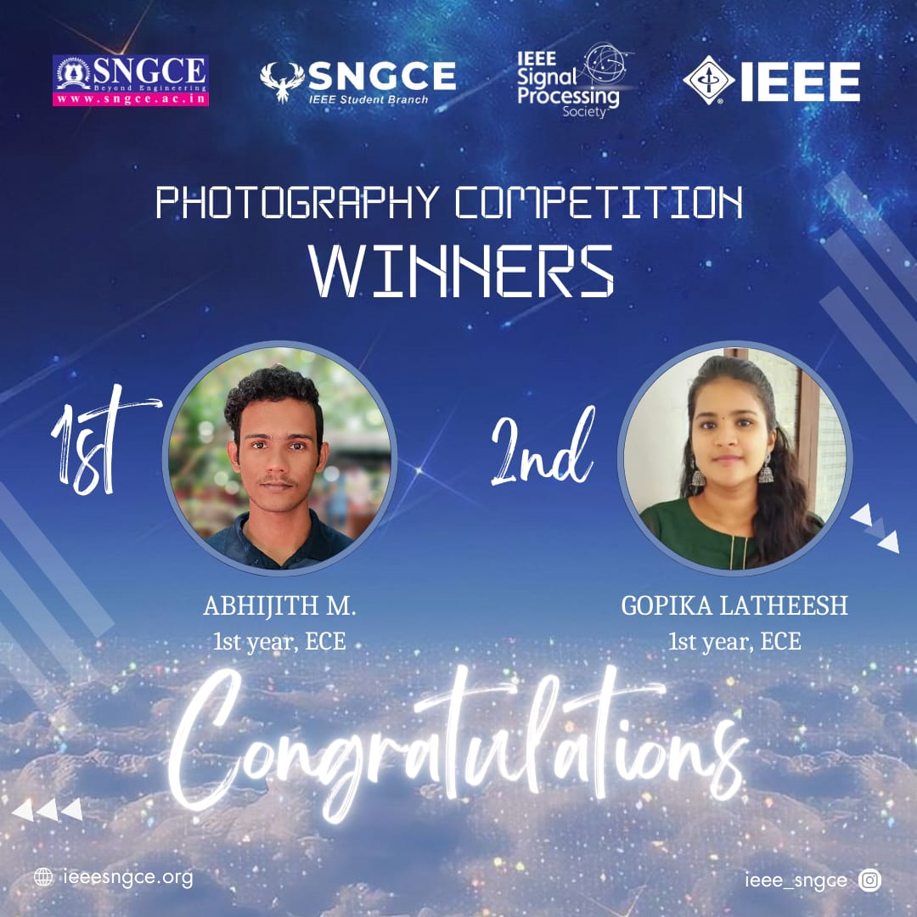

EXECOM MEETING

Mode : Online
Participation Count : 4
Date : 10th September 2023
Time : 10 PM

IEEE SPS SNGCE conducted an exe com meeting to discuss and plan for the upcoming events. The execom share their ideas for the future events and how to make society active and alive. We had also discussed how to conduct membership drive to increase the members in our society. The meeting also focused on areas which we need development and also the importance of reporting and documentation on events. The meeting was very productive and successful

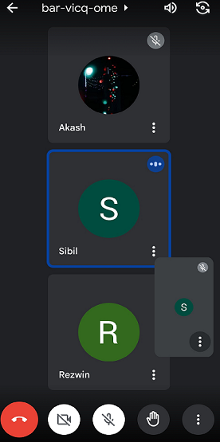

ENGINEER’S DAY QUIZ COMPETITION

Mode : Online
Participation Count : 42
Date : 15th September 2023
Time : 9:30 pm

IEEE SPS SNGCE conducted a quiz competition on behalf of Engineer’s day on 15th september 2023.The quiz comprised of 42 participants. A google form is provided to the participants to register for the competition .The informations and guidelines regarding the quiz competition is provided through whatsapp group.
The quiz began at 9:30pm sharp and the quiz consisted of a total of 20 multiple choice questions and provided 10 minutes to complete . The selection process for winners was purely based on their scores .Top three were awarded as winners.

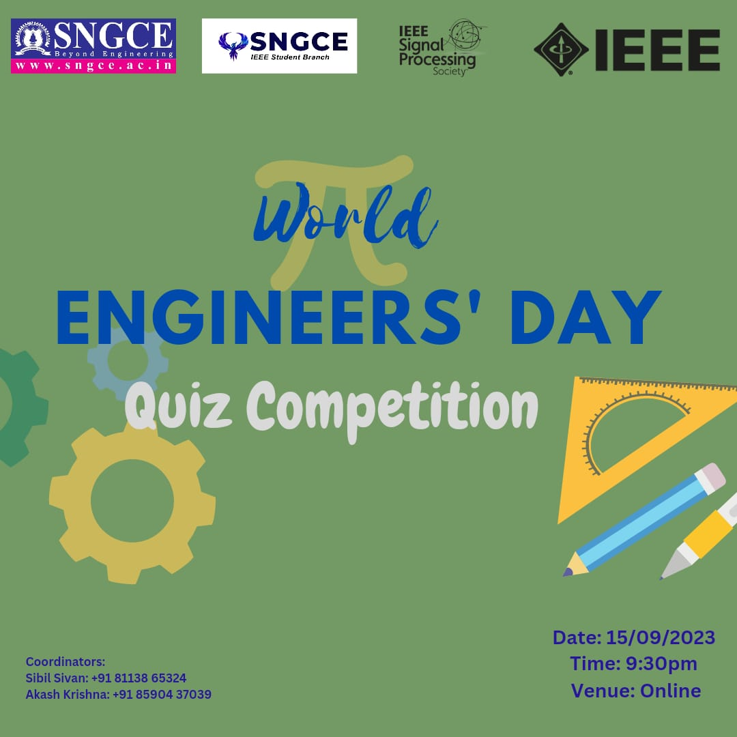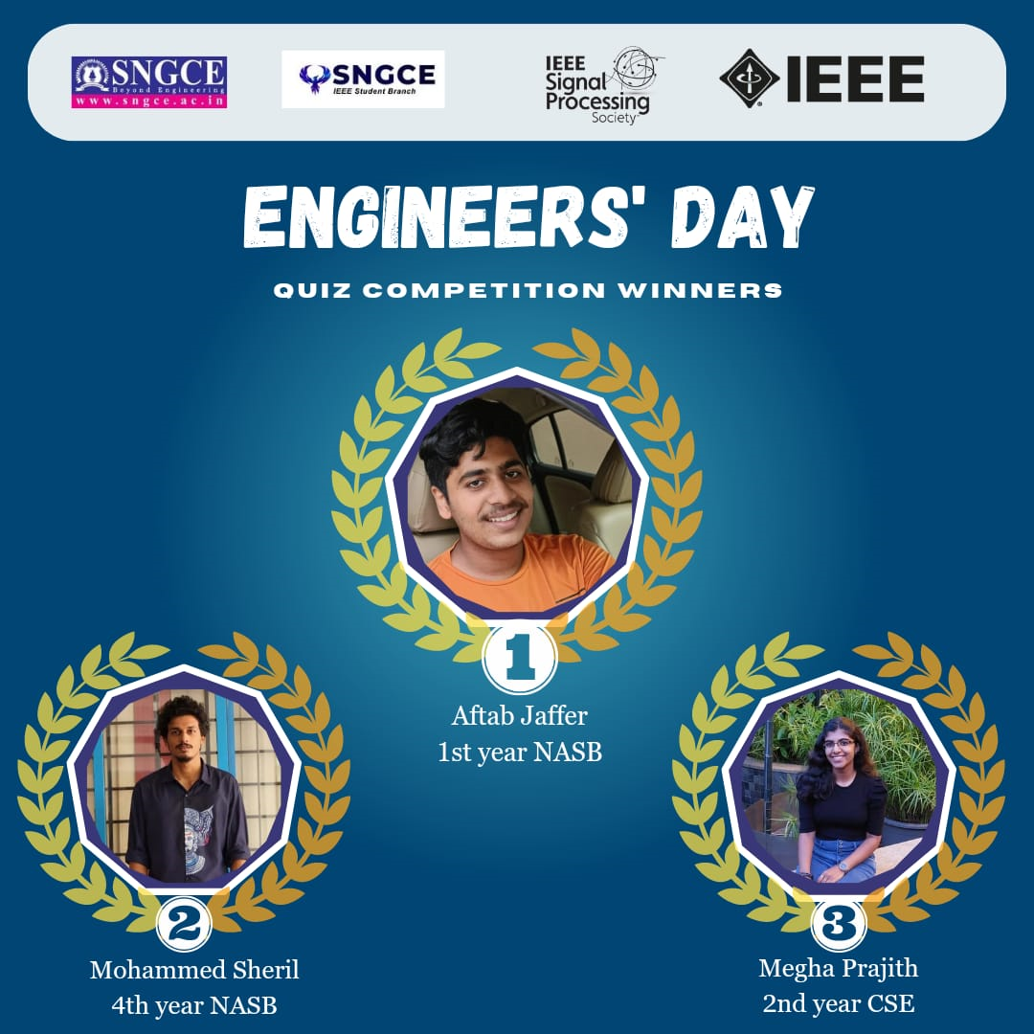

WEBINAR

Mode : Online
Participation Count : 45
- IEEE Members : 30
- Non IEEE Members : 15
Date : 25th September 2023
Time : 7 PM

IEEE SPS SNGCE AND ENTRI App jointly organized a webinar on “Career in Management Through Management Exams”. The session was handled by C. Sivabhaskaran, M.Sc., M.Phil, MBA, PGDCA, Aptitude Trainer with 15+years experience.
The session covered insights about cracking Management exams like CAT/MAT and provided guidance to get into top B-Schools like IIMS. The webinar helps the participants to gain insights from an accomplished expert and clear their queries.

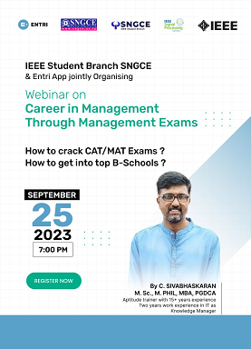

HANDS ON WORKSHOP -WEEK 1
INTRODUCTION TO PYTHON PROGRAMMING

Mode : offline
Participation Count : 95
Date : 27th September 2023
Time : 1:30pm-4:30pm

IEEE SPS SNGCE conducted a hands-on workshop on introduction to python programming. The event was handled by our expert instructor Dr.Pratibha Varghese , Assoc. Professor of ECE and Branch Counselor of IEEE SB SNGCE. She guided the participants through the step by step process. The workshop was designed to empower the students with essential skills in python programming. This session helps the participants to create an amazing hands-on experience with python programming. Overall the event was very successful

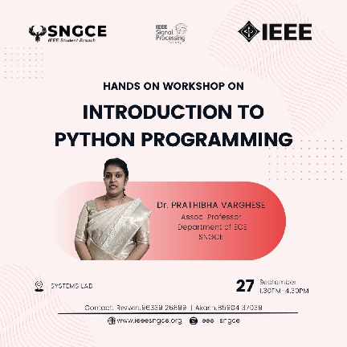
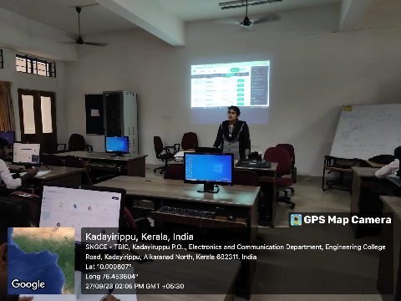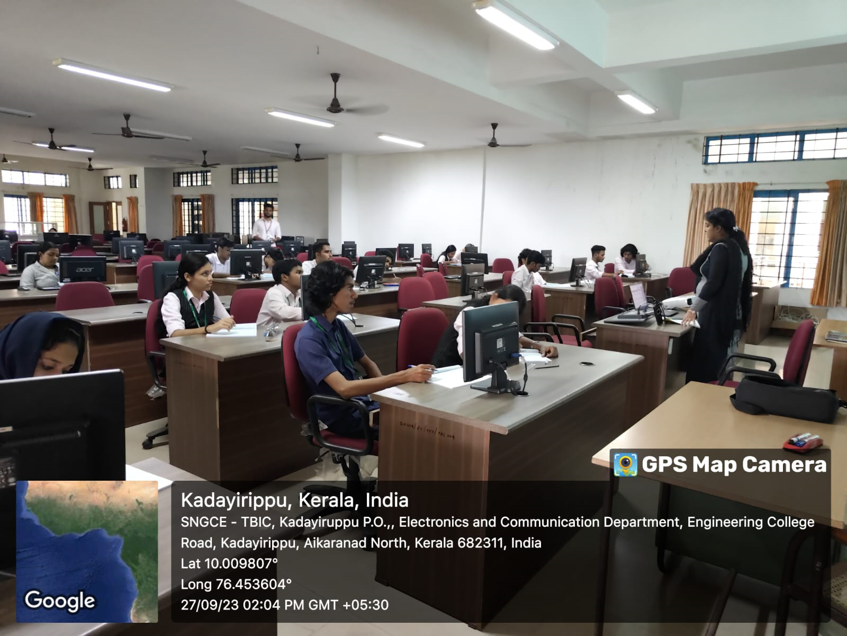

HANDS ON WORKSHOP- WEEK 2
MATPLOTLIB-VISUALIZATION WITH PYTHON

Mode : Offline
Participation Count : 50
Date : 18th October 2023
Time : 1:30pm-4:30pm

IEEE SPS SNGCE conducted an immersive and enlightening WEEK 2 workshop on “MATPLOTLIB-VISUALIZATION WITH PYTHON”. Matplotlib is a comprehensive library for creating static, animated, and interactive visualizations in Python. The session was handled by our expert instructor Dr. Prathibha Varghese Assoc. professor ECE and Branch Counselor IEEE SB SNGCE. She guided the participants through the step-by-step process. The workshop was designed to empower the students with essential skills in python programming. The students were able to learn a lot more information about python programming. Through this workshop we were able to create an amazing opportunity to provide a hands-on experience with python programming to the participants. Overall the event was very successful.
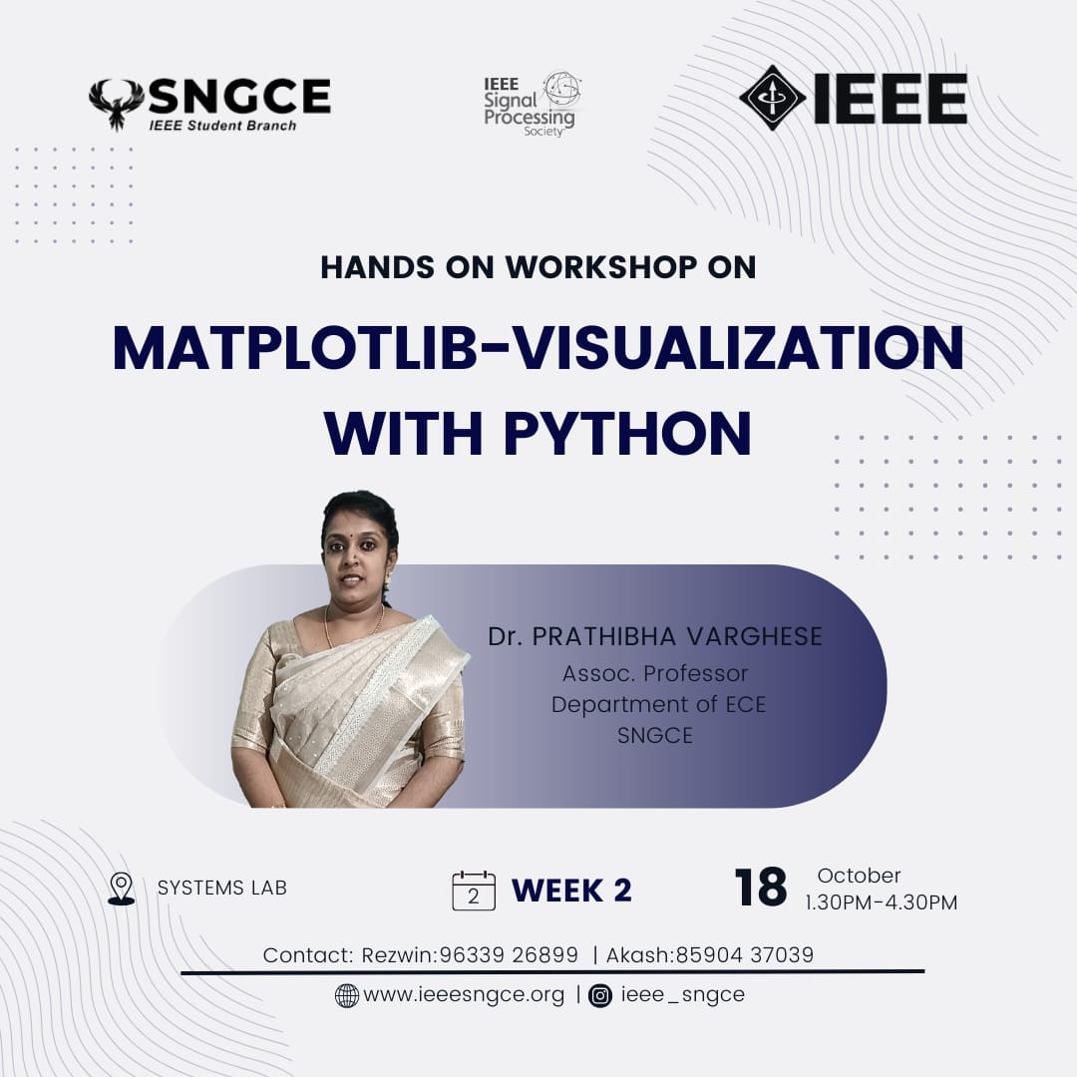

HANDS ON WORKSHOP- WEEK 3
PYTHON FOR NUMERICAL DIFFERENTIAL AND INTEGRATION

Mode : Offline
Participation Count : 46
Date : 1st November 2023
Time : 1:30pm-4:30pm

IEEE SPS SNGCE conducted an immersive and enlightening WEEK 3 workshop on “PYTHON FOR NUMERICAL DIFFERENTIAL AND INTEGRATION”. The session was handled by our expert instructor Dr. Prathibha Varghese Assoc.Professor ECE and Branch Counselor IEEE SB SNGCE. She guided the participants through the step-by-step process. The workshop was designed to empower the students with essential skills in python programming. The students were able to learn a lot more information about python programming. Through this workshop we were able to create an amazing opportunity to provide a hands-on experience with python programming to the participants. Overall the event was very successful.
